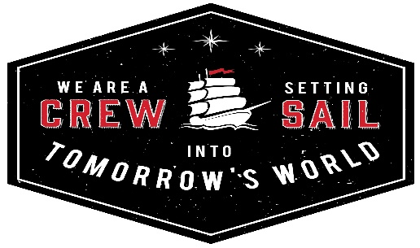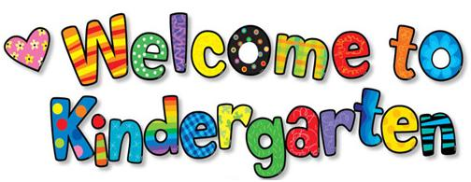
Palencia Elementary School
http://www-pes.stjohns.k12.fl.us
Information for 2018-2019 Kindergarten Families
Screenings Monday, July 16th – Wednesday, July 18th 9:00 AM-1:00 PM
- New kindergarten students meet one-on-one with a Palencia Elementary Kindergarten teacher. During this optional screener, students will be asked to identify letters/sounds, basic numeracy skills, colors, shapes, and sight words.

- Please arrive 15 minutes early to ensure that all registration paperwork has been completed.

- A Kindergarten Screening sign-up genius is on the front page of the Palencia website. Pick a day and time that works for you! A limited number of make-up sessions will be available the week of July 30th.
iPads IPads are used daily in kindergarten classrooms as a learning tool. Students utilize a variety of educational apps under the direction of the teacher. A full list of apps used will be provided the first weeks of school.
Staggered Start In KINDERGARTEN ONLY, students do not all start on Friday, August 10th. Instead, a handful of Kindergarteners attend the first four days using a staggered start process. Small groups of Kindergarten students come August 10th, 13th, 14th, and 15th. All Kindergarteners come on Thursday, August 16th. A Sign up Genius will be available on the Palencia Elementary website once homeroom teachers are announced. Parents will then choose ONE of the following for their student’s staggered start 1st day:
Friday, Aug. 10th Monday, Aug. 13th Tuesday, Aug.14th Wednesday, Aug. 15th
School Access Anyone who wants to visit the classroom or lunchroom MUST be a cleared volunteer. Visit the PES website to register. http://www-pes.stjohns.k12.fl.us/volunteers/
Mark your calendars!
Wednesday, August 8th | 5:30pm -7:00pm | Kindergarten Meet the Teacher | Parents and students stop by to meet their teacher.
Thursday, August 16th | 8:30am-2:50pm | First FULL DAY for ALL Kindergarten students
Tuesday, August 28th | 6:00pm -7:00pm | Kindergarten  Curriculum Chat | For parents, there will be a presentation and Q&A with all kindergarten teachers and admin.

Wednesday  August 8 |  |  | You and your K student stop by to meet their teacher!!
Tuesday  August 28 |  |  | An adult evening- your chance to learn about what your child does/has been doing during the day. There will be a presentation and Q and A session with ALL of the Kindergarten Teachers and administration.

